Theater For The New City
155 First Avenue (9th and 10th street), New York, NY 10003
Reservations & Info 212-254-1109 www.theaterforthenewcity.net www.facebook.com/theaterforthenewcity

Vendor Participation needed!

Theater for the New City is holding its
24th Annual Lower East Side Festival of the Arts!

The LES Festival will take place over Memorial Day Weekend. On Saturday, May 25th, as part of the outdoor portion of our Festival, we will close down East 10th Street between 1st and 2nd Avenue for a Cultural Street Festival. We are seeking vendors to sell crafts, goods, food, jewelry, artwork and the like as part of this event. There will also be performances taking place in the street. The event will take place from 10am to 6pm.

Participating vendors will receive a 10'x10' space. Your space is secured by paying a participation fee of $75, plus providing us with a copy of your Dept. of Consumer Affairs Street Vendor license. This fee is non-refundable unless we must cancel due to bad weather, in which case your fee will be refunded.

Vendors must provide their own tables, chairs and supplies, and are responsible for cleaning up after themselves at the end of the event.

Please make Check or Money Order for $75.00 payable to:
Theater for the New City
155 1st Avenue
New York, NY 10003
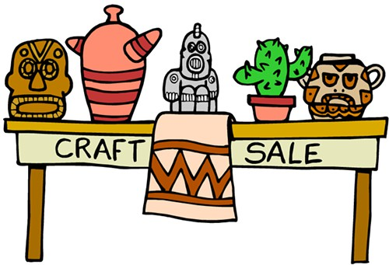

Vendor Name:______________________________________________________________________

Mailing Address: __________________________________________________________________

Telephone Number________________________________________________________________

Email Address:_____________________________________________________________________

Participating Vendors must supply a copy of your Dept. of Consumer Affairs Street Vendor License. More info available at: https://www1.nyc.gov/nyc-resources/service/2594/temporary-street-fair-vendor-permit.

